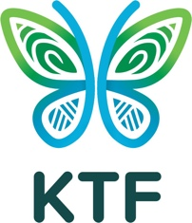

Child Protection Incident Notification Tool
This form is to be completed by any individual who suspects or receives an allegation regarding non child safe behaviour, including:
- child exploitation and/or abuse
- possession of any child exploitation material
- breach of KTF’s Child Protection Policy or Child Protection Code of Conduct
- criminal proceedings being undertaken in regard to child exploitation and/or abuse.
This form must be emailed to the Chair of the Child Protection Working Group, Hannah Ryan (hannah@kokodatrackfoundation.org)
Name of person lodging the Form:

Contact details of person lodging the Form (address/ phone number/ email address):
Date/s of Incident/s:

Name of organisation/s involved:

Alleged offender’s details including name, nationality and occupation or relationship to KTF or Implementing Partner organisation:
Details of alleged incident/s (including age and details of victim, location, response to date, is the victim still in danger:

Whether local law enforcement authorities, child protection authorities and/or Australian Federal Police have been involved:
If incident/s occurred in the course of a KTF activity or KTF funded activity, the name of the activity:
If incident/s occurred in the course of a DFAT funded KTF activity? If so, additional reporting to DFAT required immediately.
Any other relevant information:

Signature:

Date:

